|  |  |  |
| --- | --- | --- |
| Alexander Souza G00317835 | June 19  2014 | |
| . | | Project Report GPS/GSM Springboard GMIT |

https://encrypted-tbn0.gstatic.com/images?q=tbn:ANd9GcSV7qR-caT7Ro_X_UdazksG-3GVCZYBlVrU9hthXv8RsI37A0_Adg



A

Arduino 5

Arduino Software 9

B

Block Diagram 8

C

Conclusion 15

D

Data Logger Module Logging Shield Data Recorder 7

Debugging 15

F

Features 4

Firmware 11

G

Google Maps 10

H

Hardware 5

I

I2C Arduino LCD 2004 20x4 Character 6

Introduction 3

P

Project 3

Project Report 3

S

SIEMENS TC35 SMS GSM Module 5

Skylab UART Serial GPS Module 6

Software 9

T

Temperature Sensors TMP35 7

Project Report

# Introduction

A GPS tracking unit is a device that uses the Global Positioning System to determine the precise location of a vehicle, person, or other asset to which it is attached and to record the position of the asset at regular intervals. The recorded location data can be stored within the tracking unit, or it may be transmitted to a central location data base, or internet-connected computer, using a cellular (GPRS or SMS), radio, or satellite modem embedded in the unit. This allows the asset's location to be displayed against a map backdrop either in real time or whenanalysing the track later, using GPS tracking software. Data tracking software is available for smartphones with GPS capability.

Source <http://en.wikipedia.org/wiki/Gps_tracking>

## Project

For some time, I have been interested in making some sort of GPS based on the Arduino platform. This project is the first phase of this longer-term hobby project.

Now we are clear that the Arduino will send the SMS using the GSM module by keeping the GPS location in the SMS, which is obtained, from the GPS module, or save the trace information to an SD card.

### Features

1 - Speed ​​on Display, SD and SMS

2 - Number of Satellites on Display

3 - Speed ​​Alert in Display, LED, Buzzer, SD and SMS

4 - Start recording on SD, only when get GPS signal

5 - Sending GPS position Google Maps as SMS reply.

6 - Storage temperature SD, show the display and return SMS.

7 - SOS button (Sending GPS position Google Maps)

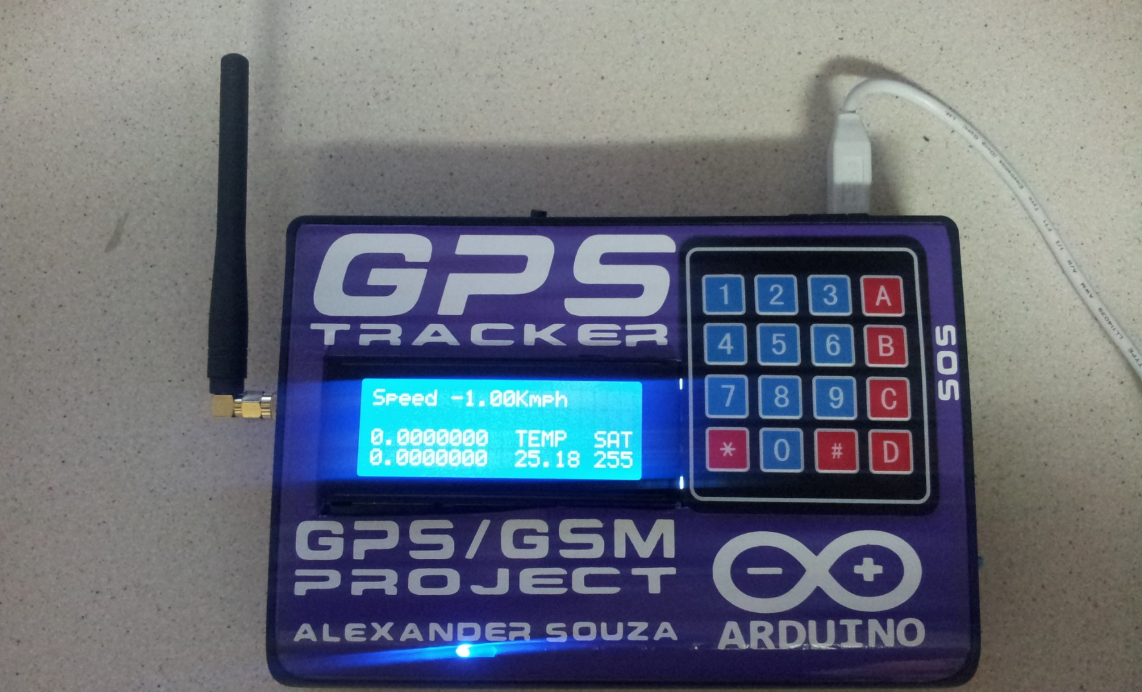

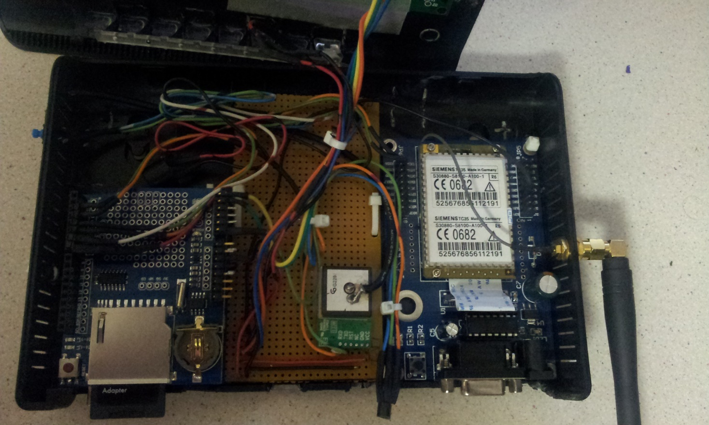

# Hardware

## Arduino UNO

Arduino is a single-board microcontroller, intended to make the application of interactive objects or environments more accessible. The hardware consists of an open-source hardware board designed around an 8-bit Atmel AVR microcontroller, or a 32-bit Atmel ARM. Current models feature a USB interface, 6 analog input pins, as well as 14 digital I/O pins which allows the user to attach various extension boards.

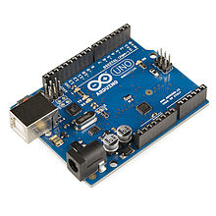

## SIEMENS TC35 SMS GSM Module

The SIEMENS TC35 Module is AT Command - controlled gsm modem, via Serial Port (RS232/TTL communication).

## http://www.sainsmart.com/media/catalog/product/cache/1/image/265x265/9df78eab33525d08d6e5fb8d27136e95/i/m/img_3048.jpg

## Skylab UART Serial GPS Module

SKM53 Series with embedded GPS antenna.It is based on MediaTek3329 single-chip architecture.SKM53 can be applied in a portable device and receiver like PND, GPS mouse, car holder, personal locator, speed camera detector and vehicle locator.

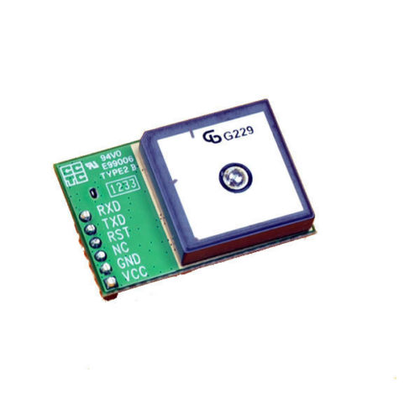

## I2C Arduino LCD 2004 20x4 Character

This is IIC Serial 20X4 LCD module . With this I2C interface LCD module.

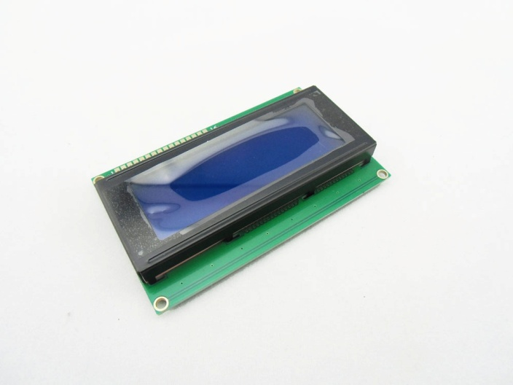

## Data Logger Module Logging Shield Data Recorder

SD card interface works with FAT16 or FAT32 formatted cards. 3.3v level shifter circuitry prevents damage to your SD card 2. Real time clock (RTC) keeps the time going even when the Arduino is unplugged.

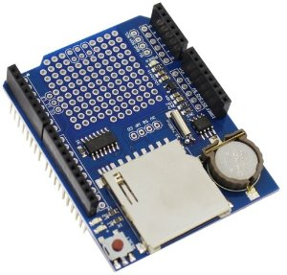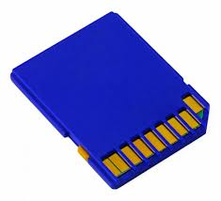

## TEMPERATURE SENSORS TMP35

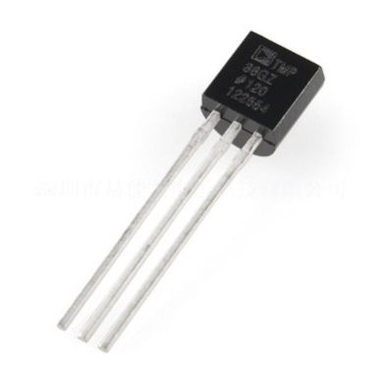

## Block Diagram

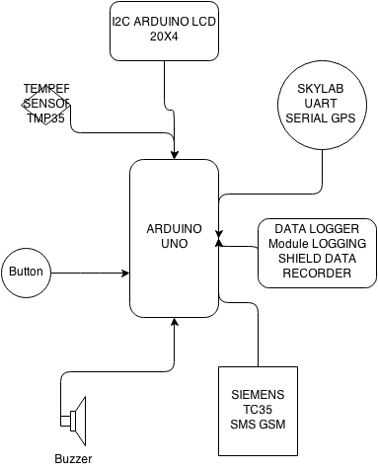

# Software

## Arduino Software

Development of the program code official Arduino IDE, which can be installed starting the site was used <http://arduino.cc/>

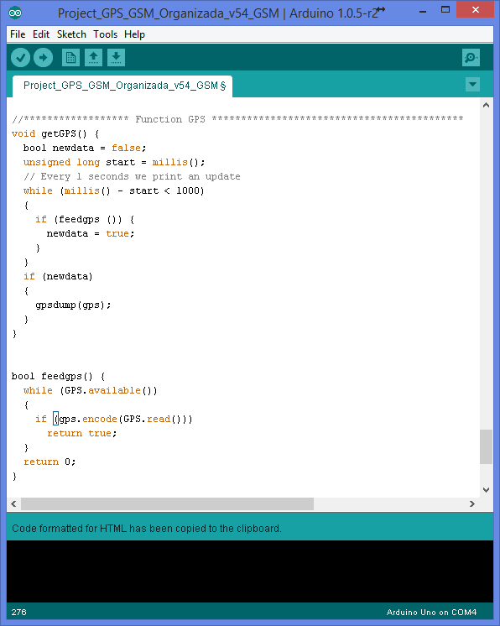

## Google Maps

Using the platform of Google Drive, you can import the data collected by GPS and saved to SD in GPSLOG.CSV file.

This Google tool lets you view the coordinates on Google Maps.

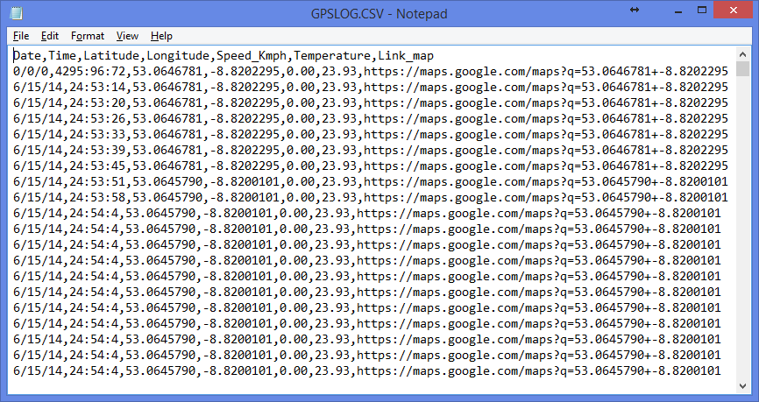

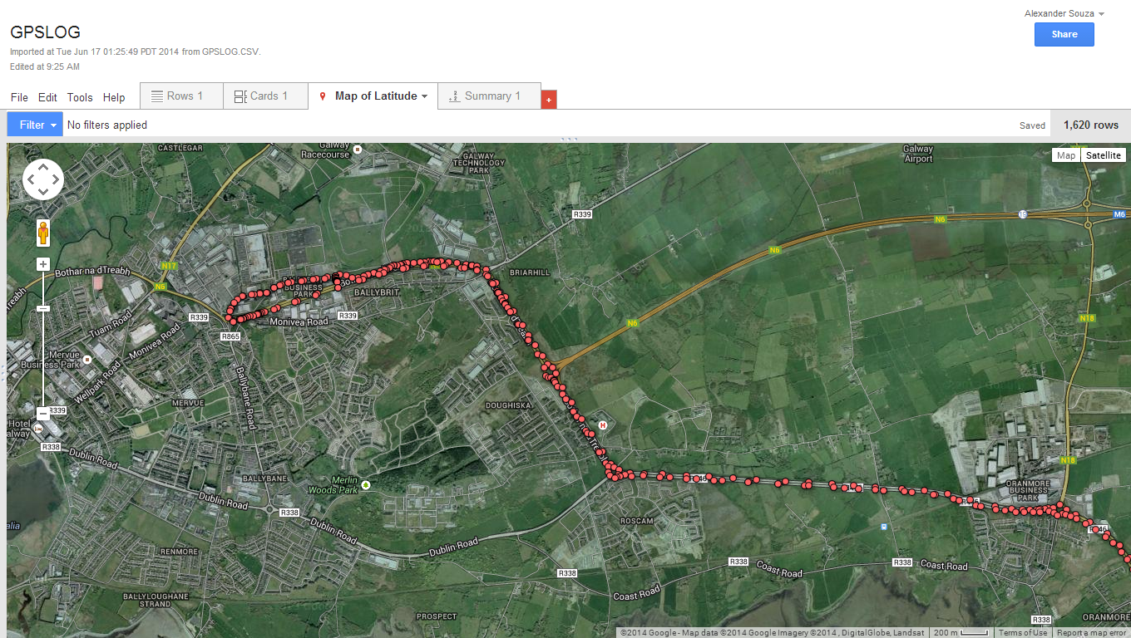

# Firmware

// Bibliotecas Obrigatorias

#include <Wire.h>

#include <LiquidCrystal_I2C.h>

#include <TinyGPS.h>

#include <SoftwareSerial.h>

#include <SPI.h>

#include <SD.h>

// Endereco LCD

LiquidCrystal_I2C lcd(0x27, 2, 1, 0, 4, 5, 6, 7, 3, POSITIVE);

// Variaveis

SoftwareSerialGPS(2, 3);

SoftwareSerialgsmSerial(5,4);

TinyGPSgps;

voidgpsdump(TinyGPS&gps);

boolfeedgps();

voidgetGPS();

float LAT, LON;

longlat, lon, year, month, day, hour, minute, second, velocity;

unsigned long fix_age, time, date, speed, course, chars;

unsigned short sentences, failed_checksum;

float temp;

inttempPin = 0;

//Configuracao SD shields para pin 10

constintchipSelect = 10;

void setup()

{

gsmSerial.begin(9600);

GPS.begin(9600);

Serial.begin(115200);

// Serial.begin(9600);

lcd.begin(20, 4);

pinMode(7, OUTPUT); // Buzzer

pinMode(6, INPUT); // BUtton

pinMode(10, OUTPUT);

if (!SD.begin(chipSelect)) {

lcd.setCursor(0, 0);

lcd.print("initialization failed!");

return;

}

lcd.setCursor(0, 0);

lcd.print("initialization done.");

delay(1000);

// Informacoes de LCD

lcd.setCursor(0, 0);

lcd.print("Project GPS/GSM V53");

lcd.setCursor(0, 1);

lcd.print("Alexander Souza");

tone(7, 2000, 1000);

delay(4000);

lcd.backlight();

lcd.setCursor(0, 0);

lcd.print(" ");

lcd.setCursor(0, 1);

lcd.print(" ");

lcd.setCursor(0, 2);

lcd.print(" ");

lcd.setCursor(0, 3);

lcd.print(" ");

}

void loop()

{

digitalWrite(4, LOW);//Enable GSM mode

digitalWrite(5, LOW);//Enable GSM mode

digitalWrite(2, HIGH);//Disable GPS mode

digitalWrite(3, HIGH);//Disable GPS mode

// AdquirirPosicao, data e hora GPS

gps.get_position(&lat, &lon, &fix_age);

gps.get_datetime(&date, &time, &fix_age);

gps.f_speed_kmph();

year = date % 100;

month = (date / 100) % 100;

day = date / 10000;

hour = time / 1000000;

minute = (time / 10000) % 100;

second = (time / 100) % 100;

temp = analogRead(tempPin); // AdquirindoTemperatura

temp = temp * 0.48828125;

getGPS();

// coodenadas GPS no LCD

lcd.setCursor(0, 0);

lcd.print("Speed");

lcd.setCursor(6, 0);

lcd.print(gps.f_speed_kmph()); // VelocidadeKmph

lcd.setCursor(11, 0);

lcd.print("Kmph");

// lcd.setCursor(0, 1);

// lcd.print("Recording... ");

lcd.setCursor(0, 2);

//lcd.print("Lat:");

//lcd.setCursor(4, 2);

lcd.print(LAT / 100000, 7);

lcd.setCursor(0, 3);

//lcd.print("Lon:");

//lcd.setCursor(4, 3);

lcd.print(LON / 100000, 7);

lcd.setCursor(11, 2);

lcd.print("TEMP SAT");

lcd.setCursor(17, 3);

lcd.print(gps.satellites()); // Numero de satelitesdisponivel

lcd.setCursor(11, 3);

lcd.print(temp-0.70);

if (day != 0) { // Condicao para gravar o GPSLOG somente quando adquirir sinal GPS, Verificao feita pela a variavel dia

// Prosseco de Gravacao e Verificacao do arquivo GPSLOG.csv

File myFile = SD.open("gpslog.csv", FILE_WRITE);

// Alterar o estado do Arquivo para OPEN

if (myFile) {

feedgps(); // If we don't feed the gps during this long routine, we may drop characters and get checksum errors

// Campos a serem gravados no arquivo gpslog.csv

myFile.print(month);

myFile.print("/");

myFile.print(day);

myFile.print("/");

myFile.print(year);

myFile.print(",");

myFile.print(hour+1);

myFile.print(":");

myFile.print(minute);

myFile.print(":");

myFile.print(second);

myFile.print(",");

myFile.print(LAT / 100000, 7);

myFile.print(",");

myFile.print(LON / 100000, 7);

myFile.print(",");

myFile.print(gps.f_speed_kmph());

myFile.print(",");

myFile.print(temp-0.70);

myFile.print(",");

myFile.print("https://maps.google.com/maps?q=");

myFile.print(LAT / 100000, 7);

myFile.print("+");

myFile.print(LON / 100000, 7);

myFile.println("");

myFile.close();

lcd.setCursor(17, 0);

lcd.print("Rec");

}

else {

lcd.setCursor(17, 0);

lcd.print("Err");

}

}

delay(2000); // Tempo de Recolha para os dados esta definido para 5 segundos

lcd.setCursor(0, 1);

lcd.print(" ");

if(digitalRead(6)){

digitalWrite(2, LOW);//Disable GPS mode

digitalWrite(3, LOW);//Disable GPS mode

digitalWrite(4, HIGH);//Enable GSM mode

digitalWrite(5, HIGH);//Enable GSM mode

//gsmSerial.begin(9600);

gsmSerial.print("AT+CMGF=1\r");

delay(100);

gsmSerial.println("AT+CMGS=\"+353877687528\"");

delay(100);

gsmSerial.print("Speed Kmph: ");

gsmSerial.println(gps.f_speed_kmph());

gsmSerial.print("Temp C.: ");

gsmSerial.println(temp);

gsmSerial.println("");

gsmSerial.print("https://maps.google.com/maps?q=");

gsmSerial.print(LAT / 100000, 7);

gsmSerial.print("+");

gsmSerial.print(LON / 100000, 7);

delay(100);

gsmSerial.println((char)26);

lcd.setCursor(0, 1);

lcd.print("Send My GPS Location");

tone(7, 1500, 1000);

//GPS.begin(9600);

digitalWrite(4, LOW);//Enable GSM mode

digitalWrite(5, LOW);//Enable GSM mode

digitalWrite(2, HIGH);//Disable GPS mode

digitalWrite(3, HIGH);//Disable GPS mode

}

}

//****************** Function GPS *******************************************

voidgetGPS() {

boolnewdata = false;

unsigned long start = millis();

// Every 1 seconds we print an update

while (millis() - start < 1000)

{

if (feedgps ()) {

newdata = true;

}

}

if (newdata)

{

gpsdump(gps);

}

}

boolfeedgps() {

while (GPS.available())

{

if (gps.encode(GPS.read()))

return true;

}

return 0;

}

voidgpsdump(TinyGPS&gps)

{

//byte month, day, hour, minute, second, hundredths;

gps.get_position(&lat, &lon);

LAT = lat;

LON = lon;

//gps.f_speed_kmph();

velocity = gps.speed();

{

feedgps(); // If we don't feed the gps during this long routine, we may drop characters and get checksum errors

}

}

# Debugging

A problem that took me a long time was the malfunction , the problem is my GPS shield shuting down when the GPRS Shield done to store the data.

The software serial port conflict, GPS and GSM shields both use serial ports. While receiving a GPS signal, GSM is switched off, and when a signal is acquired, the GPS turns off and GSM begin to work.

# Conclusion

For me this was a big challenge, having never programmed in Arduino or have any knowledge with GPS or GSM, I learned a lot from the mistakes.

I also learned that it is not necessary to know a lot of electronics to build something interesting, just a desire to learn.

# Thanks

I thank all the Lecturers of GMIT, by a strong desire to teach, and all who share their knowledge on the internet.